Ammar Ahmed BDS2B2
20L-0961

Lab 10 Tasks
Input |  | Output
S’ | R’ | Q | Q’ | Set state
0 | 1 | 1 | 0 | Set state
1 | 1 | 1 | 0 | Reset state
1 | 0 | 0 | 1 | Reset state
1 | 1 | 0 | 1 | Undefined
0 | 0 | 1 | 1 | Undefined

Question 1: S’R’ latch Truth Table

S’R’ latch combinational circuit, using NAND

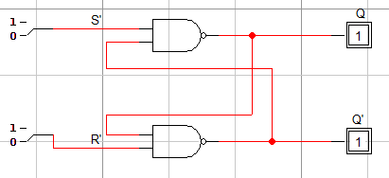
Timing Diagram:

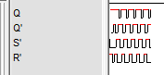

Question 2: SR latch Truth Table
Input |  | Output
S | R | Q | Q’ | Set state
1 | 0 | 1 | 0 | Set state
0 | 0 | 1 | 0 | Reset state
0 | 1 | 0 | 1 | Reset state
0 | 0 | 0 | 1 | Undefined
1 | 1 | 0 | 0 | Undefined

SR latch combinational circuit, using NOR

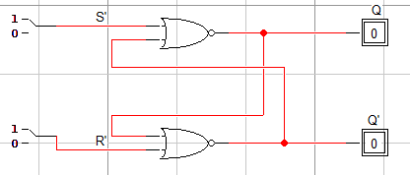
Timing Diagram

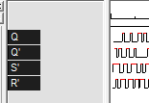

Question 3: S’R’ latch with Control Input Truth Table
Input |  |  | Output
C | S’ | R’ | Q | Q’
0 | X | X | X | X
1 | 0 | 1 | 0 | 1
1 | 0 | 0 | 0 | 1
1 | 1 | 0 | 1 | 0
1 | 0 | 0 | 1 | 0
1 | 1 | 1 | Undefined

S’R’ latch with Control Input combinational circuit

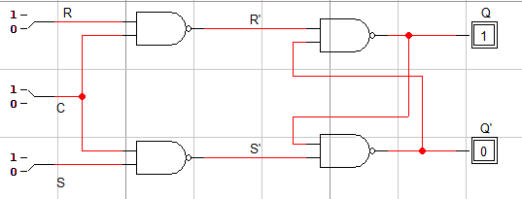
Timing Diagram

